Screenshot of Lab Task 5 and 6
Woon Xin Ying
105198939
Lab Task 5.1
https://github.com/Sharonwoon/DataVIsualisationLab/blob/main/Lab5.1.html
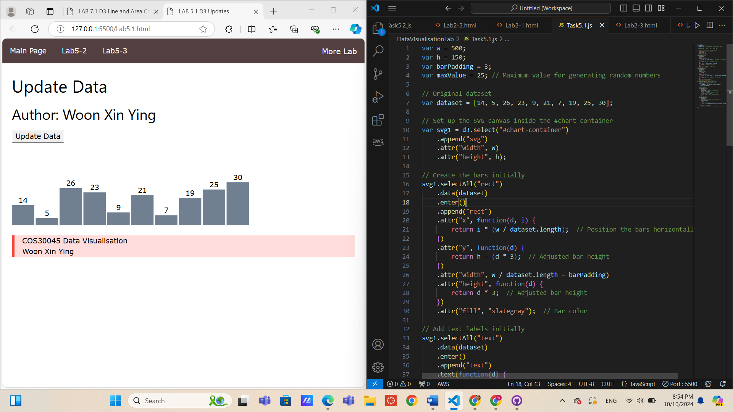

Lab Task 5.2
https://github.com/Sharonwoon/DataVIsualisationLab/blob/main/Lab5-2.html
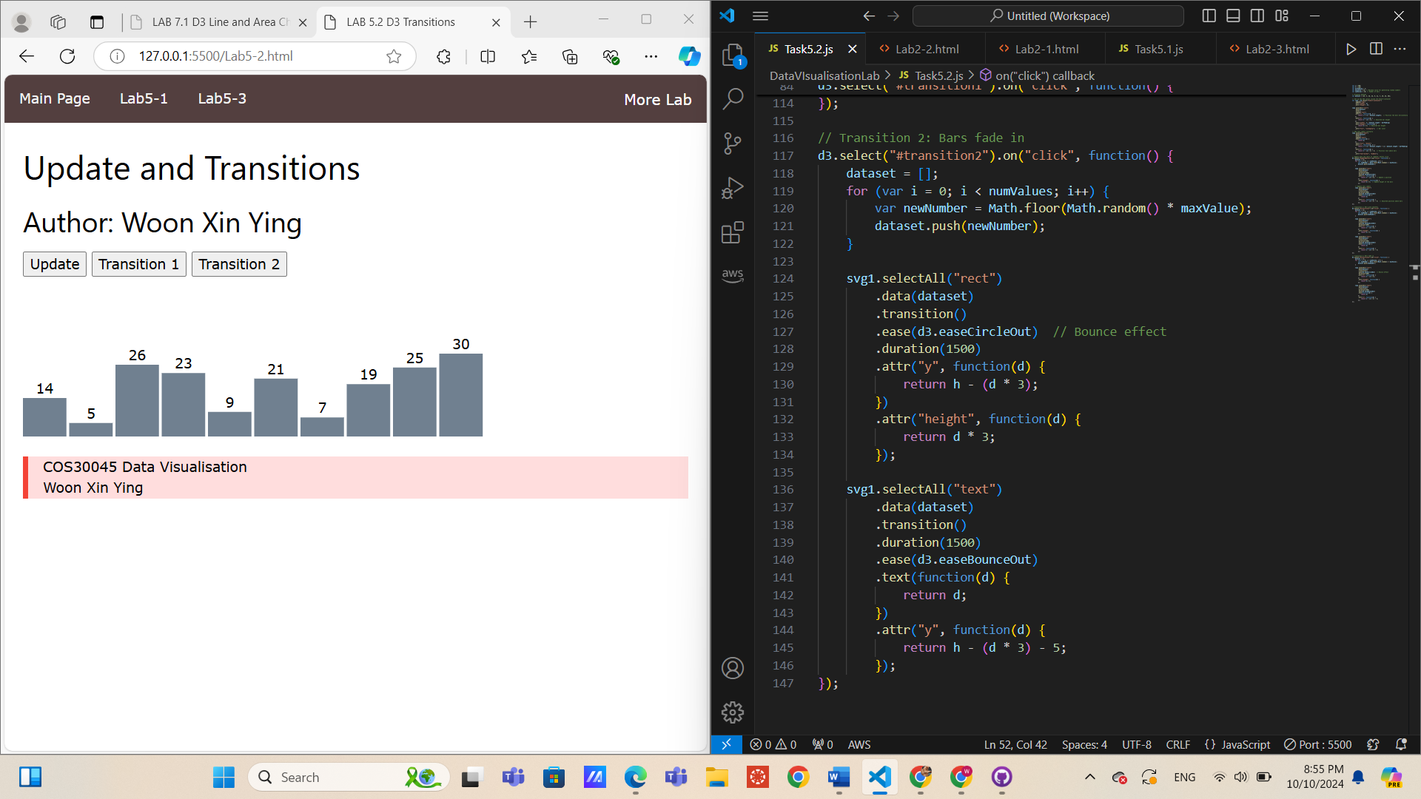

Lab Task 5.3
https://github.com/Sharonwoon/DataVIsualisationLab/blob/main/Lab5-3.html

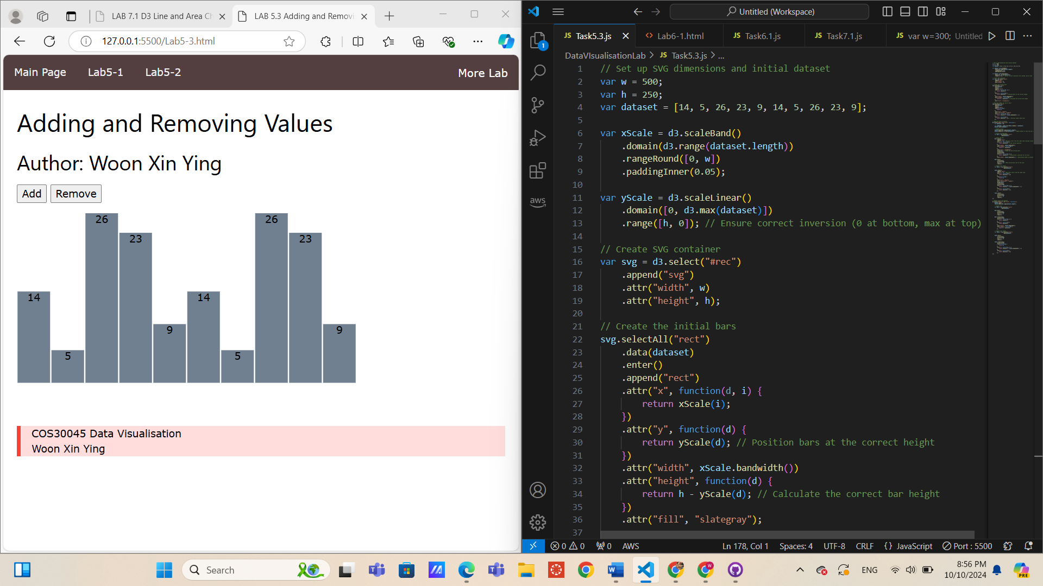

Lab Task 6.1
https://github.com/Sharonwoon/DataVIsualisationLab/blob/main/Lab6-1.html
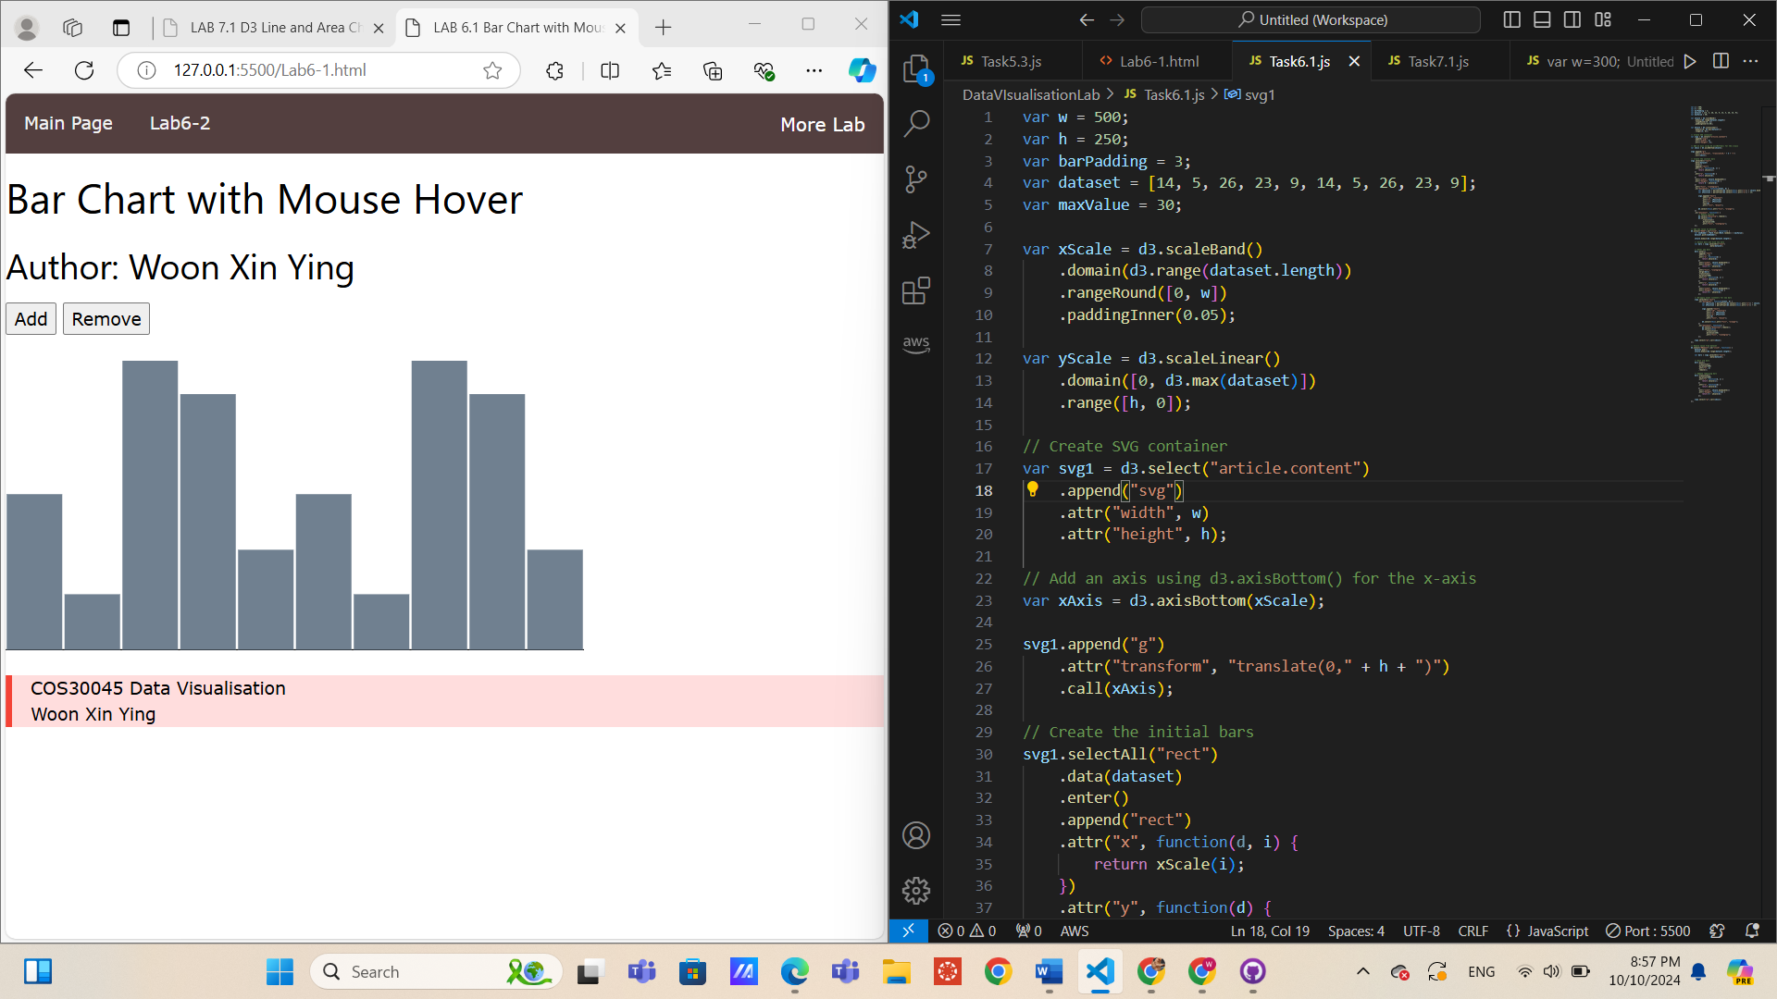

Lab Task 6.2
https://github.com/Sharonwoon/DataVIsualisationLab/blob/main/Lab6-2.html
